Bashontika

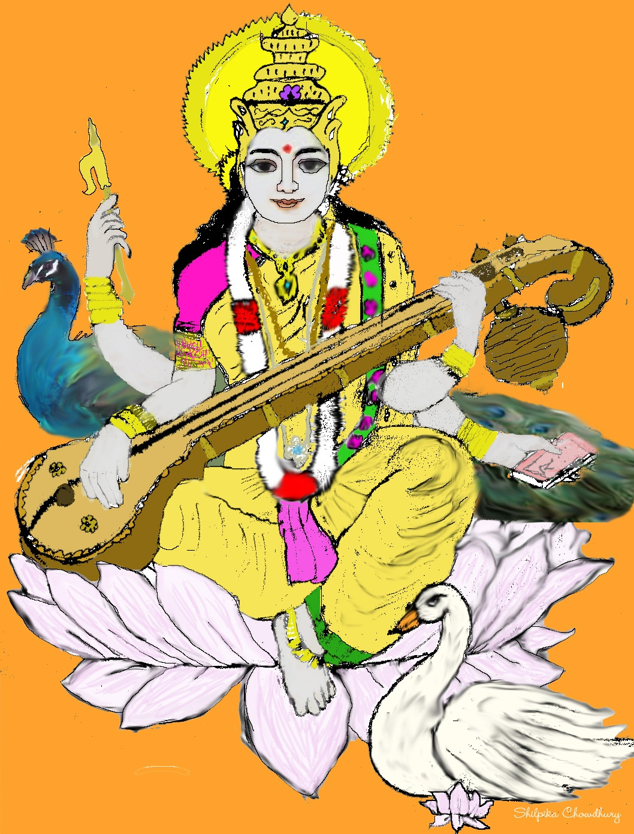

Bengali Cultural Association of Arizona
Spring, 2005

Bengali Cultural Association of Arizona


BCAA

Bashontika



Magazine and Membership Directory

Saraswati Puja
Spring 2005

Message from the Board

___________________________________

Dear Community members:

On behalf of the Bengali Cultural Association of Arizona we wish you all a very happy New Year. 2005 has started off as a year of changes and challenges - the Indian Ocean tsunami impacts from the end of last year, the interesting rainy winter weather in the valley, the changes in the BCAA board members to name just a few. We thank the 2004 BCAA committee for the wonderful work they did.

As you know, due to changes in circumstances, some of the elected BCAA 2005 committee members were not able to continue, but the community rallied and we have a full new committee as of 16th Jan 2005. We also added a sixth member to the committee per the resolution passed during the general body meeting in October 2004.

Our first task of the year was to send funds to help the Tsunami victims in India. We collected $370 from the community and added to it US$2000 from BCAA funds. The funds were divided between Ramkrishna Mission Tsunami Disaster fund and Bharat Sevashram Tsunami Disaster fund. We thank all the members for your support in this worthy cause.

We also participated in the India Association hosted India Night event on Jan 29. The melodious voices of seven BCAA members filled the auditorium as they sang songs of Kazi Nazrul Islam.

The key initiatives for 2005 are as follows:
- Organizing the following events (some of these may be combined):
Saraswati Puja, Spring Picnic, Summer cultural event, Sports event, Community service event, Durga Puja, Lakhi Puja, External Artist
- Participation in cultural events organized by other Associations:
India Night, Independence Day, Discover India Diwali Mela
- Publish newsletters and magazines:
Surjosankalan May 2005, Surjosankalan Dec 2005, Bashontika, Feb 2005, Sharodargho Oct 2005
- Other Activities
Donation to Indian Ocean Tsunami Victims; Creation of a BCAA strategic fund; Supporting a Bengali school or summer camp for children
As you see we have a lot of exciting plans for the upcoming year. We need your help and support to accomplish these. We are looking forward to working with all of you in the following months.
We chose a theme of ‘Chotoder Moja’ (Children’s fun) for this magazine. We have a number of creative works by and for our young friends. Enjoy. And in the words of Dr Suess ‘Adults are obsolete children’ so all of us can enjoy.
Thank you
Sincerely
Sarbari Chowdhury (President)
Tapan Ganguly (Gen Sec)
Ritwik Mukherjee (Treasurer)
Jayati Ghoshal (Cultural Sec)
Nabanita Pal (Exec.member)
Souvik Mitra (Exec. member & Webmaster)
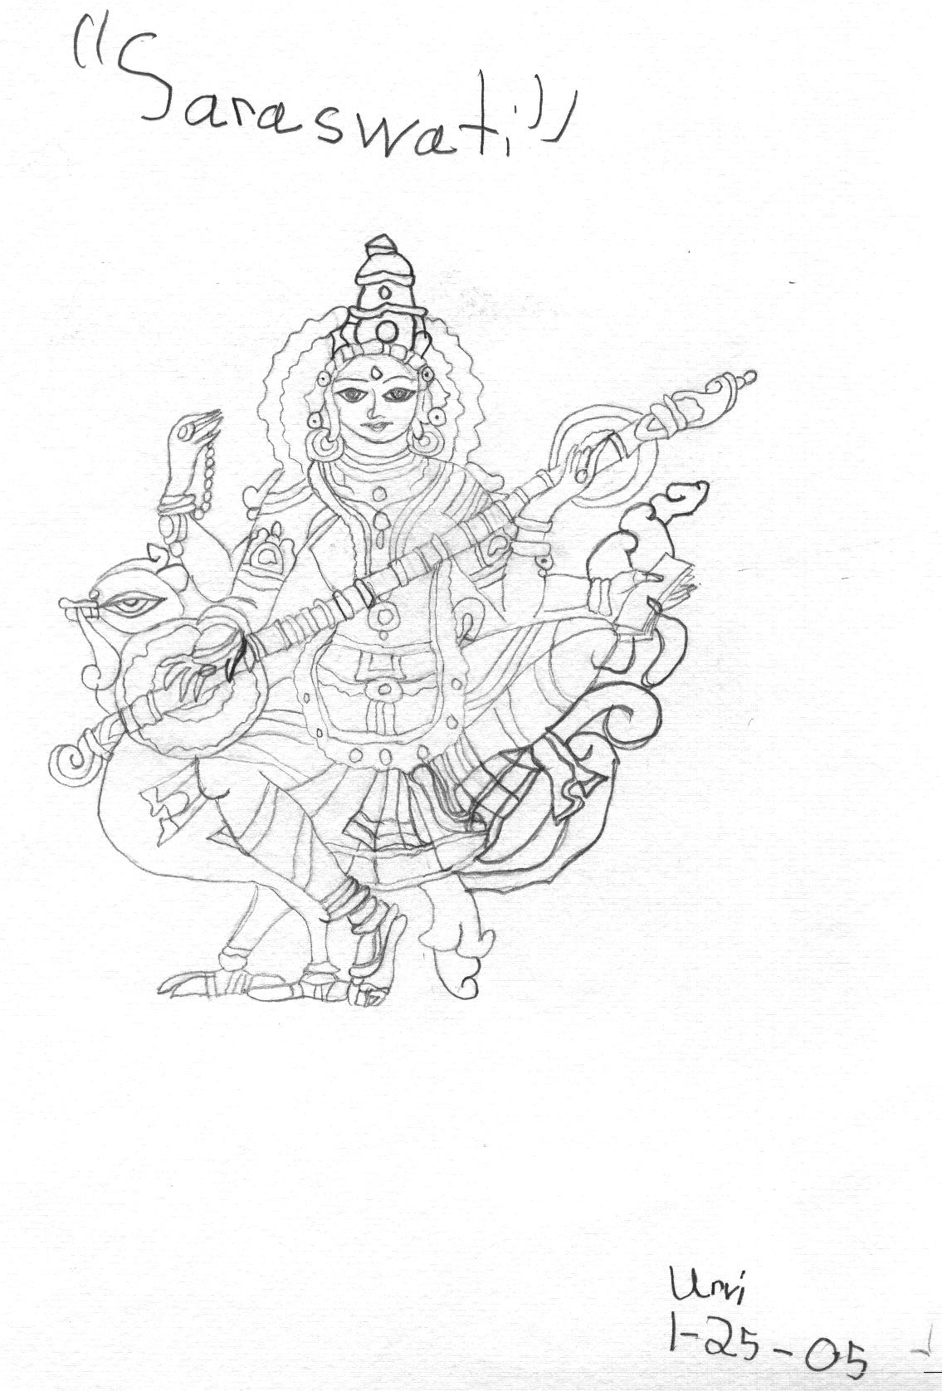
Tracing by Urvi Banerjee
There are not seven wonders of the world in the eyes of a child. There are seven million. ~Walt Streightiff
Credits: Cover Art by Shilpika Chowdhury (hand sketched, scanned, and colored on the computer)
Back Cover : Urvi Banerjee (Water color)
Puja Decoration: Murty decoration Sudipta & Soumya Biswas, Boishali & Sankhajit Chakraborty, Sampriti Bagchi, Nandita Das & Debashis Chowdhury
Editors: Sarbari Chowdhury & Sanjoy Dasgupta
Contents
__________________________________

Cultural Program 8
Cultural Program 9
Saraswati Namastubhyam… 11
In Memoriam 12
~A Small Collection of Poems~ 13
Old Memories 14
Proud to be an ABCD 15
My Messy Binder!!! 17
Hug Hungry 18
Mind Look of Ayesha 19
Rainbow Journey 19
When Elephants Did Fly 20
Snow 21
India – the Amazing Land 22
West Bengal – Aamar Shonar Bangla 23
Rapunzel’s Hair 24
Smiley Face 24
No Need for War 25
A picture for you to color 26
The Princess of the fields 27
Rain Dance 28
The boy and his drum 29
Rainy Day 31
Our Vibrant Mother-Earth 31
Prayer 34
Riddles 35
Puppies for Sale 36
Stories of the Witty Gopal 37
Food for the Mind 39
Two Frogs 41
Answers to Puzzles 42
Member Directory 45

YOUR 24/7 LOAN OFFICER
OFFERING THE DEDICATION & FULL SERVICE YOU DESERVE IN ALL YOUR MORTGAGE NEEDS:

Please visit : http://www.azrajlaons.com

Specialist in NO COST home loans

GUARANTEED LOWEST RATES

Various mortgage programs available

Full, Limited, Stated and No Ratio
Programs available on A+ through C
Up to 100% financing - Full Doc
Various ARMs – including interest only
90% LTV Cash Out on A and A- Products
90% Investor/ Second Home Cash-Out to $100,000
90% A- LTV 2x3 on mortgage history last 12 months
90% Stated Doc
Lower Rates than traditional underwriting
Loan Amounts to $2.00 million.
CONSTRUCTION/LAND/LOT LOANS AT LOW RATES

MADHU RAJ
Sr. Loan Officer

602 332 9544 Cell
623 215 2669 Fax
rajloans@cox.net email

Choice One Mortgage
11024 N. 28th Dr #250
Phoenix, AZ-85029
MB# 0901985

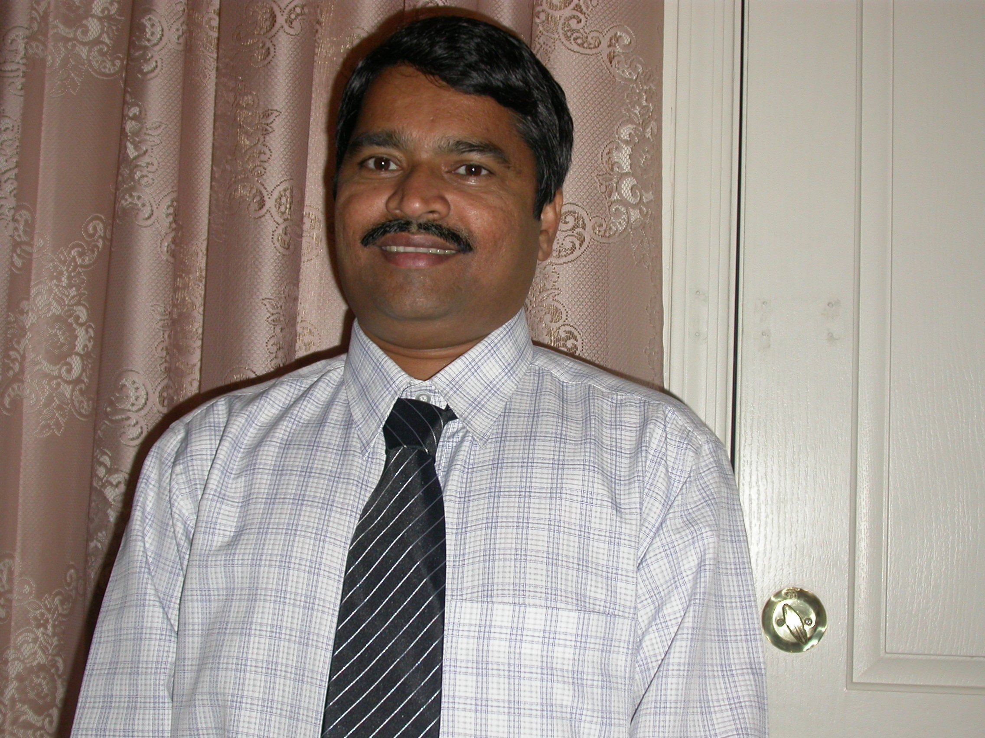
OPEN THE DOORS TO YOUR PERFECT LOAN

Cultural Program

- Announcer - Rupanjana Sengupta
- Stage Management - Jayati Ghoshal

- Sandhya Arati - Presented by the Children of the Community.
- Chanting of the Stotrams – Conducted by Barnali Banerjee
Participants: Malini Sen, Namrata Dasgupta, Urvi Banerjee, Sruti Guhathakurta, Shilpika Chowdhury, Trisha Dasgupta, Dipro Chakraborty,Amartya Sen
- Children’s Drama – “Bombagarer Raja” - Sukumar Ray
Participants: Raja - Divya Ghoshal; Rani - Isha Chakraborty; Ranir Dada – Gourav Banerjee; Montri – Devashi Ghoshal; Rajar Pishi – Somashree Biswas; Rajar Khuro – Anamika Basu; Digbaji - Sanjana Sarkar; Jyotsna Rater Lok – Amrita Chakladar And Prakriti Saha; Lepmuri Dewa Lok - Jigisha Bagchi; Pandit - Aryan Mukherjee, Ratnadeep Bandopadhay
Direction, Sound, Music And Set: Jaya Chakladar; Debjani Mukherjee; Sandeep Bagchi; Sampriti Bagchi; Baishali Chakraborty; Arundhuti Banerjee; Rekha Sarkar; Paromita Saha; Aparajita Bandopadhay; Sudipta Biswas; Gargi Basu
- Children Dance – “Maharaja Tomare Selam” – Gupi Gayen Bagha Bain
Participants: Maharaja - Abhik Chowdhury; Gupi - Rohan Ray; Bagha - Roshan Sanyal; Members of Rajsabha - Subhayon Bhattacherjee, Ronit Banerjee, Mahasweta Nayak.
Director - Meera Sanyal; Assistant Director - Sarmistha Ray; Costume Design - Meera Sanyal & Sarbari Chowdhury; Stage Decoration - Debashis Chowdhury & Prajesh Bhattacharjee
- Recitation –
Participants: Neelam Runton; Rubica Runton; Jigisha Bagchi
- Children's Bengali Folk Dance –
Participants: Main dancers: Shilpika Chowdhury; Arpita Kundu; Suravi Sengupta
Others: Ratnodip Bandyopadhyay; Isha Chakraborty; Rohon Ray; Neelam Runton; Rubica Runton;
Choreography: Rajashi Runton
- Dance - “Saraswati Vandana” And “Meera Bhajan” –
Participants: Srishti Nayak; Priya Mukherjee Puri; Natasha Mukherjee Puri
- Street Drums – Aviraj Mukherjee; Matt Sinclair
- Recitation – "Malatibala Balika Vidyalay" by Joy Goswami - Sarmistha Ray
- Dance Drama – “ O Aamar Desher Mati”
Participants: Boishali Chottopadhyay; Sutapa Barua; Mehenaz Huq; Fariah Huq; Payal Bhattacharya; Sudipta Biswas; Jayati Ghoshal; Dipshikha Das; Prajesh Bhattacharya; Anirban Das; Soumya Biswas; Pavel Ghosh; Amartyo Sen, Abhik Chowdhury, Awhona Sanyal & Anjali Sanyal
Tabla – Deepen Chakraborty; Drums – Aviraj Mukherjee; Judhajit Chakraborty;
- Modern Songs – Mayuri Ray & group.


Saraswati Namastubhyam…
________________________________________________________________
By Shristi Nayak


Across the world, millions of thousands of people utter these words under their breath as they pray to mother Saraswati on an auspicious day known as Saraswati Puja.
Saraswati, the goddess of wisdom is believed to be daughter of Shiva and Parvati. It is disputed whether she is indeed the consort of Lord Brahma, the god of wisdom, but there is no doubt that she represents purity(see legend presented below) , universal knowledge and wisdom, and mediation. She is normally portrayed as wearing a snow white garment and a necklace made of white pearls while sitting on either a peacock or swam.
It is quite easy to see why she is admired by many; however it is not exactly clear as to how Saraswati is worshipped. In fact there isn’t even a set date as to when this goddess is worshipped. (Dates usually correspond with sects of India, for example people from Bengal celebrate in during February while people from Karnataka celebrate it during October) Some worshippers pay their respects during the festival of Diwali (lights). As to the rituals, on the day of the puja all students gather to honor and ask for blessing in their future encounters. They place their books in front of her for her to bless. This is also a propitious day to begin one’s journey into the world of knowledge. Also, on this day the smallest girl in a Hindu family is adorned in a small sari (the color of the sari is normally Bashonti) to represent Saraswati. As the day goes on, flowers are laid at the idol’s feet and Prasad is passed around. Meals are always vegetarian. After this, the idol is immersed in the sea (nowadays the idol might be submerged in rivers and ponds too) to represent a farewell until next year.
We hope that you have a great Saraswati Puja!
Here is a taste of one of the legends depicting Saraswati:
The two sages Vasishtha and Vishvamitra were both violently opposed to each other. Once sage Vasishtha was practicing penance on the banks of the river Saraswati. Angry Vishvamitra ordered Saraswati to flow away Vasishtha. Saraswati hesitated for a while, but seeing furious Vishvamitra, broke through her banks where Vasishtha sat meditating. Looking Vasishtha washed away, Vishvamitra was very happy.
However, he saw that Saraswati, instead of destroying Vasishtha, is protecting him and is carrying him onto the other direction at a safer place. This angers Vishvamitra and he curses Saraswati, turning her into a river of blood.
At the behest of Shiva, the two sages became amicable and once again there was pure water in the river Saraswati.
This is why she is also referred to as Shonapunya, a Sanskrit word meaning 'one purified of blood'.
Compliments of Sify.com

In Memoriam
________________________________________________________________________

Smt. Joytara Saha

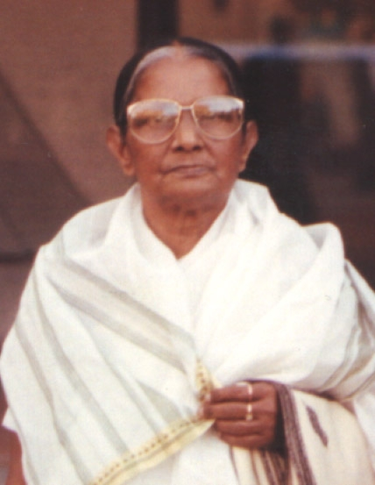

jatasya hi dhruvo mrityur
dhruvam janma mrtasya ca
tasmad apariharye ’rthe
na tvam socitum arhasi

TRANSLATION
One who has taken his birth is sure to die, and after death one is sure to take birth again. Therefore, in the unavoidable discharge of your duty, you should not lament.

PURPORT

One has to take birth according to one’s activities of life. And after finishing one term of activities, one has to die to take birth for the next. In this way one is going through one cycle of birth and death after another without liberation.

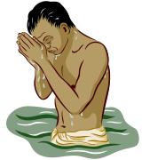


~A Small Collection of Poems~
~By Shilpika Chowdhury~
11yrs.

~*~
If joy thee does not heed,
and sadness thee conceal,
further thee should try to read,
for the following my words may reveal.
~*~
In your heart and in your soul,
where you feel you need console,
there is a place
where happiness dances with grace.
~*~
Atop the mountains towering so high,
Where the birds touch thee sky.
~*~
Clouds sprinkled everywhere,
float away without a care.
~*~
In the spring
of your thoughts
embroidered in your minds cloths
is all of your tiny shiny memory moths.


"Truly wonderful, the mind of a child is."
-- Jedi Master Yoda

Old Memories
Rounok Joardar 1/13/05
11yrs
In my closet are two boxes
the gatherings of my life.
My favorite toys,
my best school projects,
funniest pictures,
and important documents.
Now and then gazing at them,
my best achievements,
and precious moments of my life.


.

Proud to be an ABCD
by Malini Sen

I have been referred to as an American born confused desi a countless number of times by friends and family. However, I never really thought much about the comment, rather than an annoying ongoing joke until reading Namesake by Jhumpa Lahiri. I was utterly disappointed in its depiction of second generation Bengali kids in America due to its depressing outlook. This book seemed to encompass the notion of an ABCD as one who is always torn between the two cultures. After reading that book, many have asked me if it is difficult for me to live with two cultures or which one I feel closer to. In reality, I take it as a privilege. I have the chance to be completely American in jeans and T- shirts with my beloved Starbucks, malls, doughnuts, movies, music, and burgers but also deck up in the saris, ghagras, and salwar- kameez with the gorgeous jewelry while enjoying “mishti polao with mangsho.” Hindi movies on pirated VCDs are as high on my list as Friday night movies with friends. While I complain about the humidity and mosquitoes in Kolkata often, I love and will always love going to Kolkata to be utterly spoiled. Joking with my grandparents, having all the scrumptious foods at my command, reading English translated Bengali classics, having no chores whatsoever, and enjoying the chaos of Kolkata life describe my experiences during the summer holidays. On the other hand, I also immensely enjoy those typical American events, such as cheering on my high school football team at homecoming matches and getting the opportunity to go to the concerts of my favorite bands.
Living in America, kids like me do not live with extended families like ones that our parents so tremendously enjoyed. However, the friends of our parents in the community do a fabulous job of surrogate jethus, jethimas, mashis, meshos, kakas, and kakis, through whom we experience a pretty good taste of the love and care our parents received from all sides in India. Whether it is a kaka helping us with physics homework, a mashi doing our make up before puja, a jethu buying us what Ma said specifically “NO” to, or just a kaki to gossip about Hindi movies with, we always have someone to go beyond Ma and Baba. When talking to my friends at school, it’s always fun to say, ‘Oh, I have forty- something odd aunts and uncles, and a million cousins living right here in Phoenix. Plus, I get to see them every weekend, Friday, Saturday, and if I am lucky, Sunday too!” The special bond I have with my Bengali friends is one I cherish as every single one of them know me inside- out. Whether it’s talking about the strange oddities of our parents, the tally of how many times we had “macher- jhol bhath” this week, the newest CD released, or school life, these friends are people who can understand and joke about my every cultural clash with. Recently, at Durga puja, all of the kids drove down to Starbucks in their lively, colorful costumes to warm up our bodies in the chilly October weather with the “yummilicious” drinks. It was one of the most memorable experiences as we all walked into Albertson’s in our ghagras, saris, and kurtas, laughing and joking in half Bengali and English the whole way. It made me realize how lucky we truly are to not only have this American culture in us, but to also be able to confidently embrace our Indian heritage.



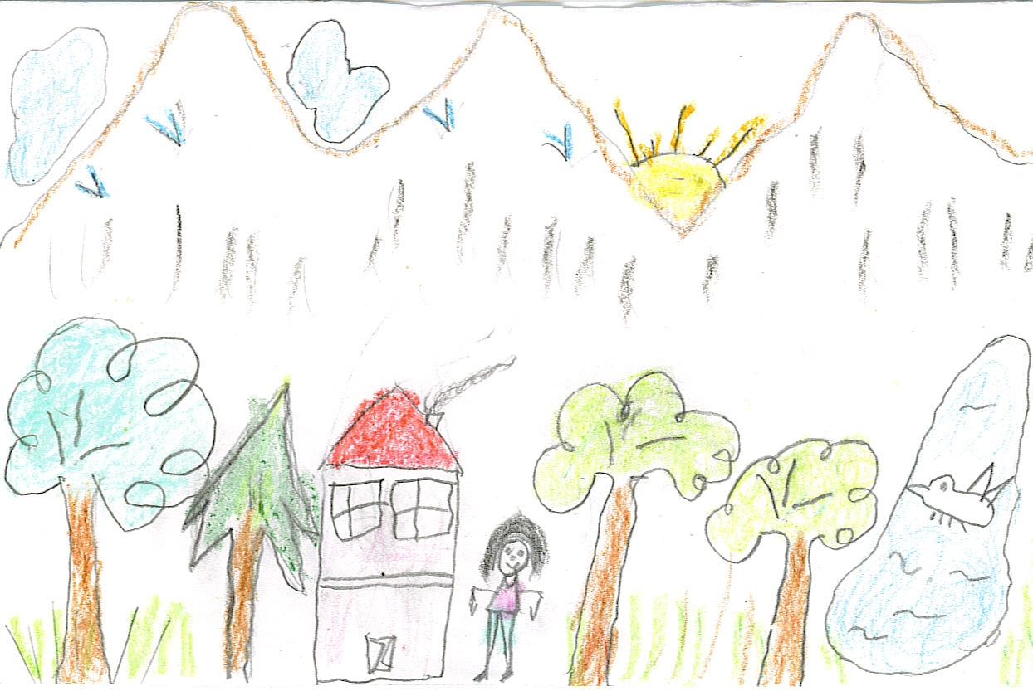

‘Aamader Bari’ – by Divya Ghoshal (4 1/2 years)

My Messy Binder!!!
Natasha Mukherjee Puri
(5th Grade)

O my! O my! O my messy binder,
It is so…. messy, I need a finder.
O dear! O dear! I do fear,
That my teacher is coming near

O where! O where! is my math,
Imagine my teacher’s wrath.
O please! O please! O help me please,
My teacher found my stinky cheese.

Hooray! Hooray! what a nice day,
My sister cleaned my binder today.
Now that I can find my math,
I do not fear my teacher’s wrath!



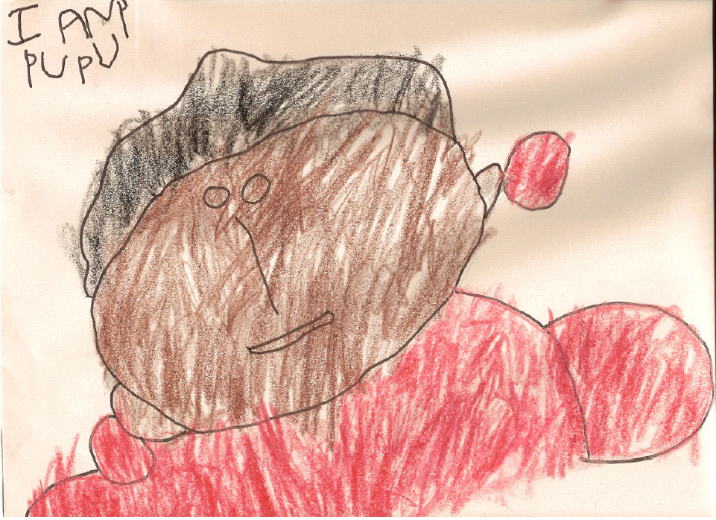
By Somashree Biswas (3 ½ years)

Hug Hungry
By Nibedita Joardar

Ever go on a diet? "Of course, who hasn’t," you ask! Have you tried them all? "Of course," you say! "But nothing works, they are so difficult!" How can everything that tastes so good be soooooo bad for you. But, still, there are lots of people who have gotten positive results from diets. People who have persevered and profited from them, have decided to sacrifice, let go, and have seen the face of success!

But ever met anybody who has survived a hug-free diet? I say no, never, nada!!! It cannot be done! No one can ever go without a hug. Especially the ones that come from little hands. I say a HUG a day keeps the doctor away. And the best part... the more the better! No more of those diets that scream, "Less! Less! Less!" The hug diet is a plain and simple "get all you can get" deal. It doesn’t cost a penny either. It may be the one free thing in life that guarantees complete happiness.

Hugs are there for the taking. Sometimes you get them just like that! For no reason -- those are the best!! And if you really want to shed a few pounds, you could make it work for you too! Run a little, skip and jump, hide and seek, or play tag... and you will be showered with more humongous hugs! And guess what, you would’ve lost some pounds too! You loose weight and humongous hugs are yours too. Do some math, write a few sentences, spell a few words, exercise that brain, and hey, did you learn something new and get more of those hugs?

A win-win situation in this world.
Hugs are the best massage you will ever get! Hugs are, by far, the best therapy for a bleak day.
So I say, never ever go hug hungry again.


Tongue twister … Say this fast: Bad money mad bunny.


Mind Look of Ayesha
Natasha Mukherjee Puri (5th Grade)

In a small town near Tehran lived a little girl named Ayesha. She was smart and teeming with curiosity and ideas. Her family was poor and lived in a governmental community where the rent was affordable. Ayesha was a happy kid and always wanted to learn and understand what was happening around her. She was especially interested in what her parents, uncles, aunts, and grandparents talked about. Recently, Ayesha’s parents seemed sad and worried and became very secretive. Ayesha found that very disturbing. Her friends in school were also experiencing the same thing. They decided to find out what was going on. Ayesha was given the responsibility to spy on her parents, conversation. She promptly found out the secrecy was regarding something called “Nuclear Weapons”. She had no clue what that was except that it is a very bad weapon and if used can destroy the whole country and all the people in the country. She told her friends in school, and they all wondered why anyone made this horrible thing in the first place. Then one day they heard on TV that the government of USA believes that Iranian government is vicious and is making these bad nuclear weapons. She and her friends were very confused since the government that they knew gave them house to live in, school to study in, and food to eat. So how can they be so bad? Then they heard something scarier, that the US will bomb them if the Iranian government did not stop making the weapon. They did not want to be in the same situation as the Iraqi children who were living in the fear of being bombed. The kids still did not know what “Nuclear Weapon” was and once again wondered as to who created such a horrible and deadly weapon. Why can’t people be friends?
~~~~ **** ~~~~

Rainbow Journey
By Rounak Joardar (11yrs.)

Joe was listening to his grandpa tell one of his stories about nature. Joe loved to listen to Grandpa's stories. Joe and his grandpa were the only ones in the family who enjoyed nature, everyone else enjoyed technology. They were all looking at Dad's new computer but Joe just wanted to listen to some more of Grandpa’s stories before it was time for him to leave. Grandpa however did not tell Joe a story. What he said next was extremely informative. “You know them rainbows, well lots of people say that it's just a trick of light, but don't believe it. Rainbows are alive. They will even grant you one wish. Not to the leprechaun, but to you. The rainbow will grant you one wish if you can pass its test. You should try it... and oh my! Take a look at that, there's a rainbow in the sky right now!"

A few minutes later Grandpa was ready to leave, but Joe was no where to be found. Joe was on his way to find that rainbow. He would wish for his grandpa to stay longer. After some walking he reached the rainbow and... wow! it didn't disappear. Instead it asked Joe to listen to all the instructions and then follow them for his wish to come true. 1. Skip around the rainbow seven times. Joe skipped around the rainbow seven times 2. Shout BINGO at a rock. Joe shouted BINGO at a rock and 3. Don't follow any of the instructions above!!! Oh no, Joe had forgotten to listen to ALL the instructions before following them. His wish would not come true. Disappointed and dejected Joe returned home. Everyone was searching for him. They all asked him where he had been and he told them his story. Then Grandpa asked Joe why he hadn't just asked him to stay, he hadn't known that Joe had ever wanted him to stay. So Joe asked "Grandpa, could you stay for a little bit longer?" And Grandpa stayed.

~~~~ * ~~~~

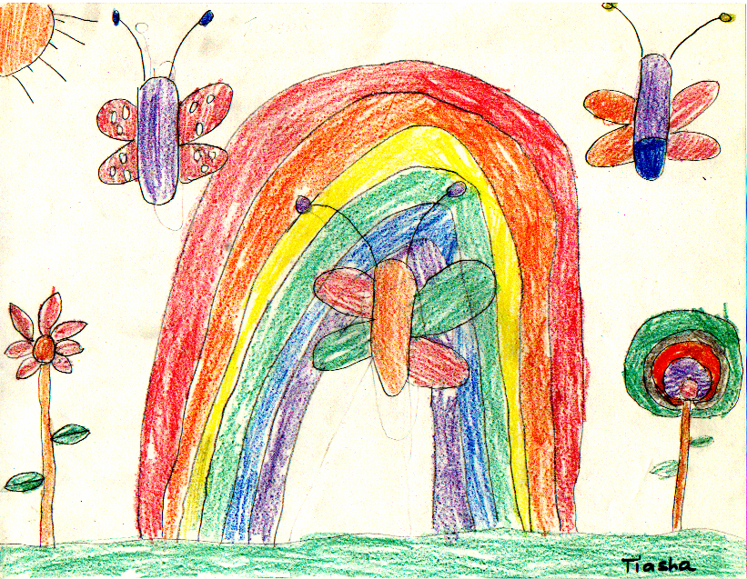

Walk on a rainbow trail; walk on a trail of song, and all about you will be beauty. There is a way out of every dark mist, over a rainbow trail.
Virginia Woolf

The Rainbow trail … by Tiasha Joardar (1st Grade)
~~~~ * ~~~~

When Elephants Did Fly

A tribal folk tale from Orissa.

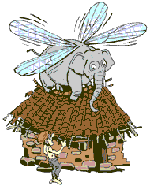
There was a time when elephants could fly. They had wings — four big wings. In fact they were God’s favorite vehicles; he used to ride on an elephant when he was busy creating the world. But once humans started living on earth and God’s work was over, their importance decreased.
Not only that, the elephants had developed very irritating habits. Sometimes they would crow like cocks. And sometimes, tired of flying in the sky, they would go and sit on the rooftops of houses. The
houses would collapse. The whole world knew how heavy the elephants were, but these creatures had no idea about the trouble they were causing.
It was time for God to take action. He invited the big beasts for a fantastic feast. The elephants stuffed themselves with so much food that once they had eaten their fill, they rolled over on their stomachs and went to sleep.
That was the moment God had been looking for. He quietly cut off the elephants’ wings. And, according to tribal lore, he gave away two of their wings to the peacock, which is how the bird got its beautiful tail.
Then God stuck the other two wings on the banana plant, which is how it got its big leaves. When the elephants woke up groggy from sleep, they discovered their great loss. And they got wild — so wild that they scampered off into the forests.

~~~~ * ~~~~



Snow
(Suravi Sengupta, 9 yrs old)

I love when it snows
the whiteness of its drop
It seems to me
that snow is a dream
as it falls from heaven to us
As we walk our way through the great white
we see what hasn’t been seen
Yet the snow is melting but don’t cry it will be back you'll see.

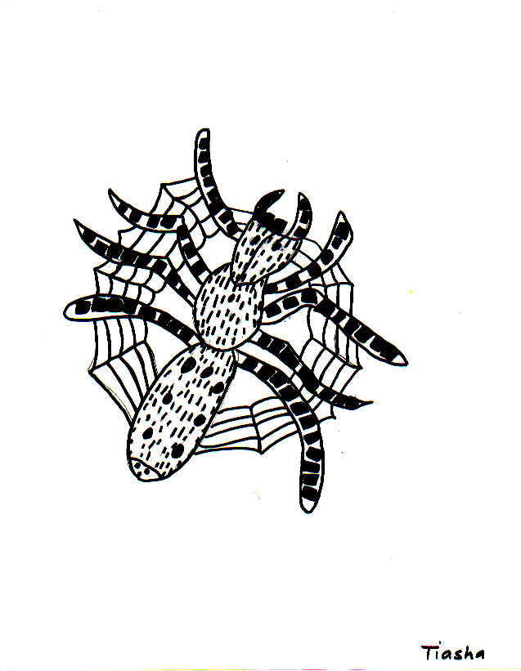
The Industrious Spider by Tiasha Joardar (1st Grade)


India – the Amazing Land

The Indus Valley civilization, one of the oldest in the world, dates back at least 5,000 years. Aryan tribes from the northwest invaded about 1500 B.C.; their merger with the earlier inhabitants created the classical Indian culture. European traders, beginning in the late 15th century, followed Arab incursions, starting in the 8th century, and Turkish in the 12th. By the 19th century, Britain had assumed political control of virtually all Indian lands. Nonviolent resistance to British colonialism under Mohandas GANDHI and Jawaharlal NEHRU led to independence in 1947. The subcontinent was divided into the secular state of India and the smaller Muslim state of Pakistan. A third war between the two countries in 1971 resulted in East Pakistan becoming the separate nation of Bangladesh.

Area: 3,287,590 sq km
Area - comparative: slightly more than one-third the size of the US
Population: 1,065,070,607 (July 2004 est.)
Ethnic groups: Indo-Aryan 72%, Dravidian 25%, Mongoloid and other 3% (2000)
Religions: Hindu 81.3%, Muslim 12%, Christian 2.3%, Sikh 1.9%, other groups including Buddhist, Jain, Parsi 2.5% (2000)
Country name: Republic of India; conventional short form: India
Capital: New Delhi
Administrative divisions: 28 states and 7 union territories; Andaman and Nicobar Islands
Literacy: total population: 59.5%; male: 70.2%; female: 48.3% (2003 est.)
National anthem Jan Gana Mana written by Rabindranath Tagore
National emblem Replica of the Lion Capital of Sarnath
National flag Horizontal tricolor in equal proportion of deep saffron on the top, white in the middle and dark green at the bottom. In the center of the white band is a wheel in navy blue color.
National animal Tiger, Panthera tigris
National bird Peacock
National flower Lotus
National tree Banyan
National fruit Mango
National currency Rupees (One Rupees = 100 Paise)

West Bengal – Aamar Shonar Bangla

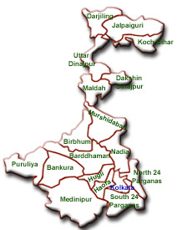
Capital Kolkata
Governor Gopalkrishna Gandhi
Chief Minister Buddhadeb Bhattacharya
The tropic of Cancer passes through West Bangal
Bengal was so important to the area that a part of the Indian ocean - Bay of Bengal is named after it.
History: During the period of the Vedic age Bengal was called Vanga. The Aryans inhabited Bengal during the post Vedic period. Many dynasties like the Palas, Pundras and Sens exercised their control over Bengal. In the beginning of the 13th century Bengal became a part of the Delhi Sultanate and later the Mughals. The proximity to the sea also resulted in the influence with the foreigners -- the Portuguese, the Dutch, the French, the Danish and British. The battle of Plassey and the battle of Buxar sealed the fate of the Mughal rule and the British came to power. Calcutta was the Capital of the British empire in India till 1911. In 1947 when India became independent Bengal was partitioned between India and Pakistan. India's share came to be known as West Bengal and Pakistan's share was called East Pakistan.
Geography: West Bengal lies in the eastern part of India. The climate of West Bengal is tropical. The land is mostly plains, except for the northern region, which is a part of Himalayan Mountain Range. Darjeeling, in the north is well known for its high quality teas. At the south of West Bengal the Sundarbans delta on Ganga is a part of the world's largest river delta (other portions lie in Bangladesh). This region is famous for the Royal Bengal Tiger.
Culture: Bengal is one of the most important cultural hubs of India. There was a saying, "What Bengal thinks today, India thinks tomorrow". It is the birthplace of India's only Noble laureate in literature, Rabindranath Tagore. The world famous film director Satyajit Ray was also born here. Apart from this, Bengal gave birth to innumerable well known poets and writers who enriched the world literature ceaselessly. Some prominent members include Kazi Nazrul Islam, Michael Madhusudan Dutt, Sarat Chandra Chattopadhyay and Bankim Chandra Chattopadhyay. Also from West Bengal is India's most beloved male singer in films, Kishore Kumar, as well as the world-famous sitar player Ravi Shankar.
Famous people: During independence movement, Bengal took a leading and especially militant role. Subhash Chandra Bose, also referred to as "Netaji", is still considered an exemplar of courage for Indian youth. Satyendra Nath Bose, from whom the boson particle and Bose-Einstein theory get their names, was also a Bengali. Amartya Sen, who won Nobel Prize in Economics in 1998 is a Bengali. Mother Teresa, winner of the Nobel Peace Prize in 1979, worked in Calcutta for most of her life.
In the religious realm, Bengal gave birth to great Hindu sages and saints like Shri Chaitanya Mahaprabhu (15th century major Vaishnava figure), Ramprasad Sen (a famous Kali Bhakta and poet) and Ramakrishna Paramhansa; others include Swami Vivekananda (the most renowned of Shri Ramakrishna's disciples), Śrī Aurobindo Ghosh, and Prabhupada A.C. Bhaktivedanta the founder of the International Society for Krishna Consciousness (ISKCON). The founder of the enlightened Bramho Samaj, Raja Ram Mohun Roy was also from this state.

Rapunzel’s Hair
by Suravi Sengupta, 9 yrs

Have you heard of the story Rapunzel? It’s a wonderful story isn't it?... well you know that she has long shiny real hair, but guess what, in my version of the story she has long shiny FALSE HAIR! And to go with that, instead of meeting her true love, the prince, she actually meets an ugly man named Rumplestiltskin. So why don't you sit back, relax, have some popcorn, and see what happened in the next paragraph.

P.S. If you didn't get this paragraph read it again and this time around don't get bored.

Once upon a time, just like any fairy tale starts out, there was a girl named Rapunzel. When she was a baby, an evil witch traded a garden full of vegetables for her and kept her in a tall tower that had a small room with no stairs but only an elevator. In the room there was a wardrobe full of Barbie clothes (which was again too small to wear), a bed, a spinning wheel, and some straw. Though Rapunzel was bald, the witch put a wig on her, so readers wouldn't be disheartened about the hair factor.

One day Rapunzel was minding her own business when she saw a small man screaming out "My name is RAMPELSTILSKIN, my name is Rampulstilskin". He kept going on and on until he saw Rapunzel and her very long hair. He bent down as if he was going to propose marriage to her, instead he said “Rapunzel , Rapunzel please let down your hair so I could climb up to get your autograph". Rapunzel knew she was a popular fairy tale character, however she had an ambition of becoming a movie star in Hollywood, therefore she liked the idea of signing the autograph. She let down her false hair and Rumplestilskin tried climbing up. Half way through, as we all correctly predicted, he fell off and off came the wig too. To make life easy, at last he found the elevator and met with Rapunzel. There they made an agreement that if Rampulstilskin spun gold from the straw she would then give him her wig.

So, if you see a Hollywood movie with a very pretty bald girl, and with a golden toothy smile you know its Rapunzel since she used the gold to make a fashionable set of teeth.(In reality she wants to start a fashion trend) And if you are standing on a screeching sliding rug at a very crowded subway station don’t feel lucky! You are actually stepping on a long silky wig that in fact is a shrieking tiny man frantically pulling at his hair and saying "EXCUSE ME, MIND YOUR STEP". Now, I shouldn’t have to introduce you to this character, you should be able to recognize him.

p.s. Let me ask you a MILLION dollar question "Who is this little guy?" If you got the answer right, you get a million dollars from the dude who got it wrong.

Smiley Face


By Abhik Chowdhury (8yrs)
Smiley faces big
Smiley faces small
Smiley faces so big
They don’t fit on the wall

No Need for War
By Avi Raj Mukherjee

The rain poured down from the night sky,
The night became darker as men yelled and cried,

Armies marched forward slaying their foes,
Many lives were lost under the trickle of falling snow,

Heroes stood up, raising their swords,
Only to fall by stampeding hordes,

Arrows flew by, mighty warriors clashed,
Limbs were torn off, heads were mashed,

A young boy stood up, raising his hands,
A blade stabbed him, ripping into his glands,

As the fell the men understood,
That fighting was wrong, stop they should,

The men left, mourning over their clouded minds,
As the night stood still, negotiation was defined.



A picture for you to color
"Every child is an artist. The problem is how to remain an artist once he grows up."
-- Pablo Picasso

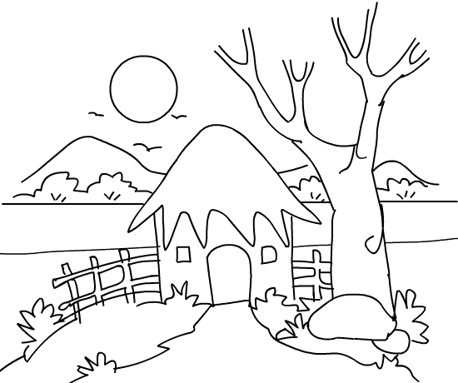

Have fun kids !!

The Princess of the fields
By Sruti Guhathakurta
(8 yrs)

A story of a field miles and miles long…………..
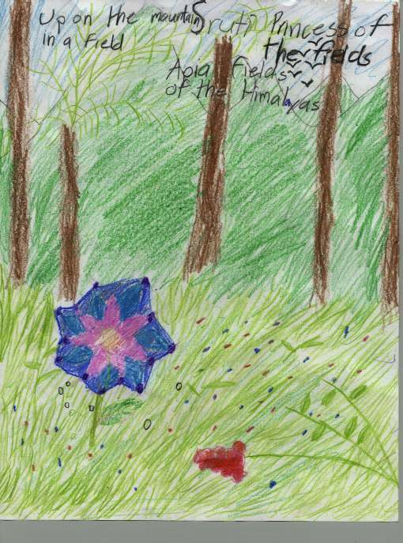

Once a man climbed up a mountain and visited one of the fields called Apia. He put up a sign there with a picture of a fake flower on it. When he came up again the population had grown in Apia. People were looking at the fake flower. They called it “Princess of the fields”. Since people liked the fake flower very much the man started selling pictures of it for fifty rupees. On Christmas day he put a Santa hat on the fake flower.

~~~~ * ~~~~

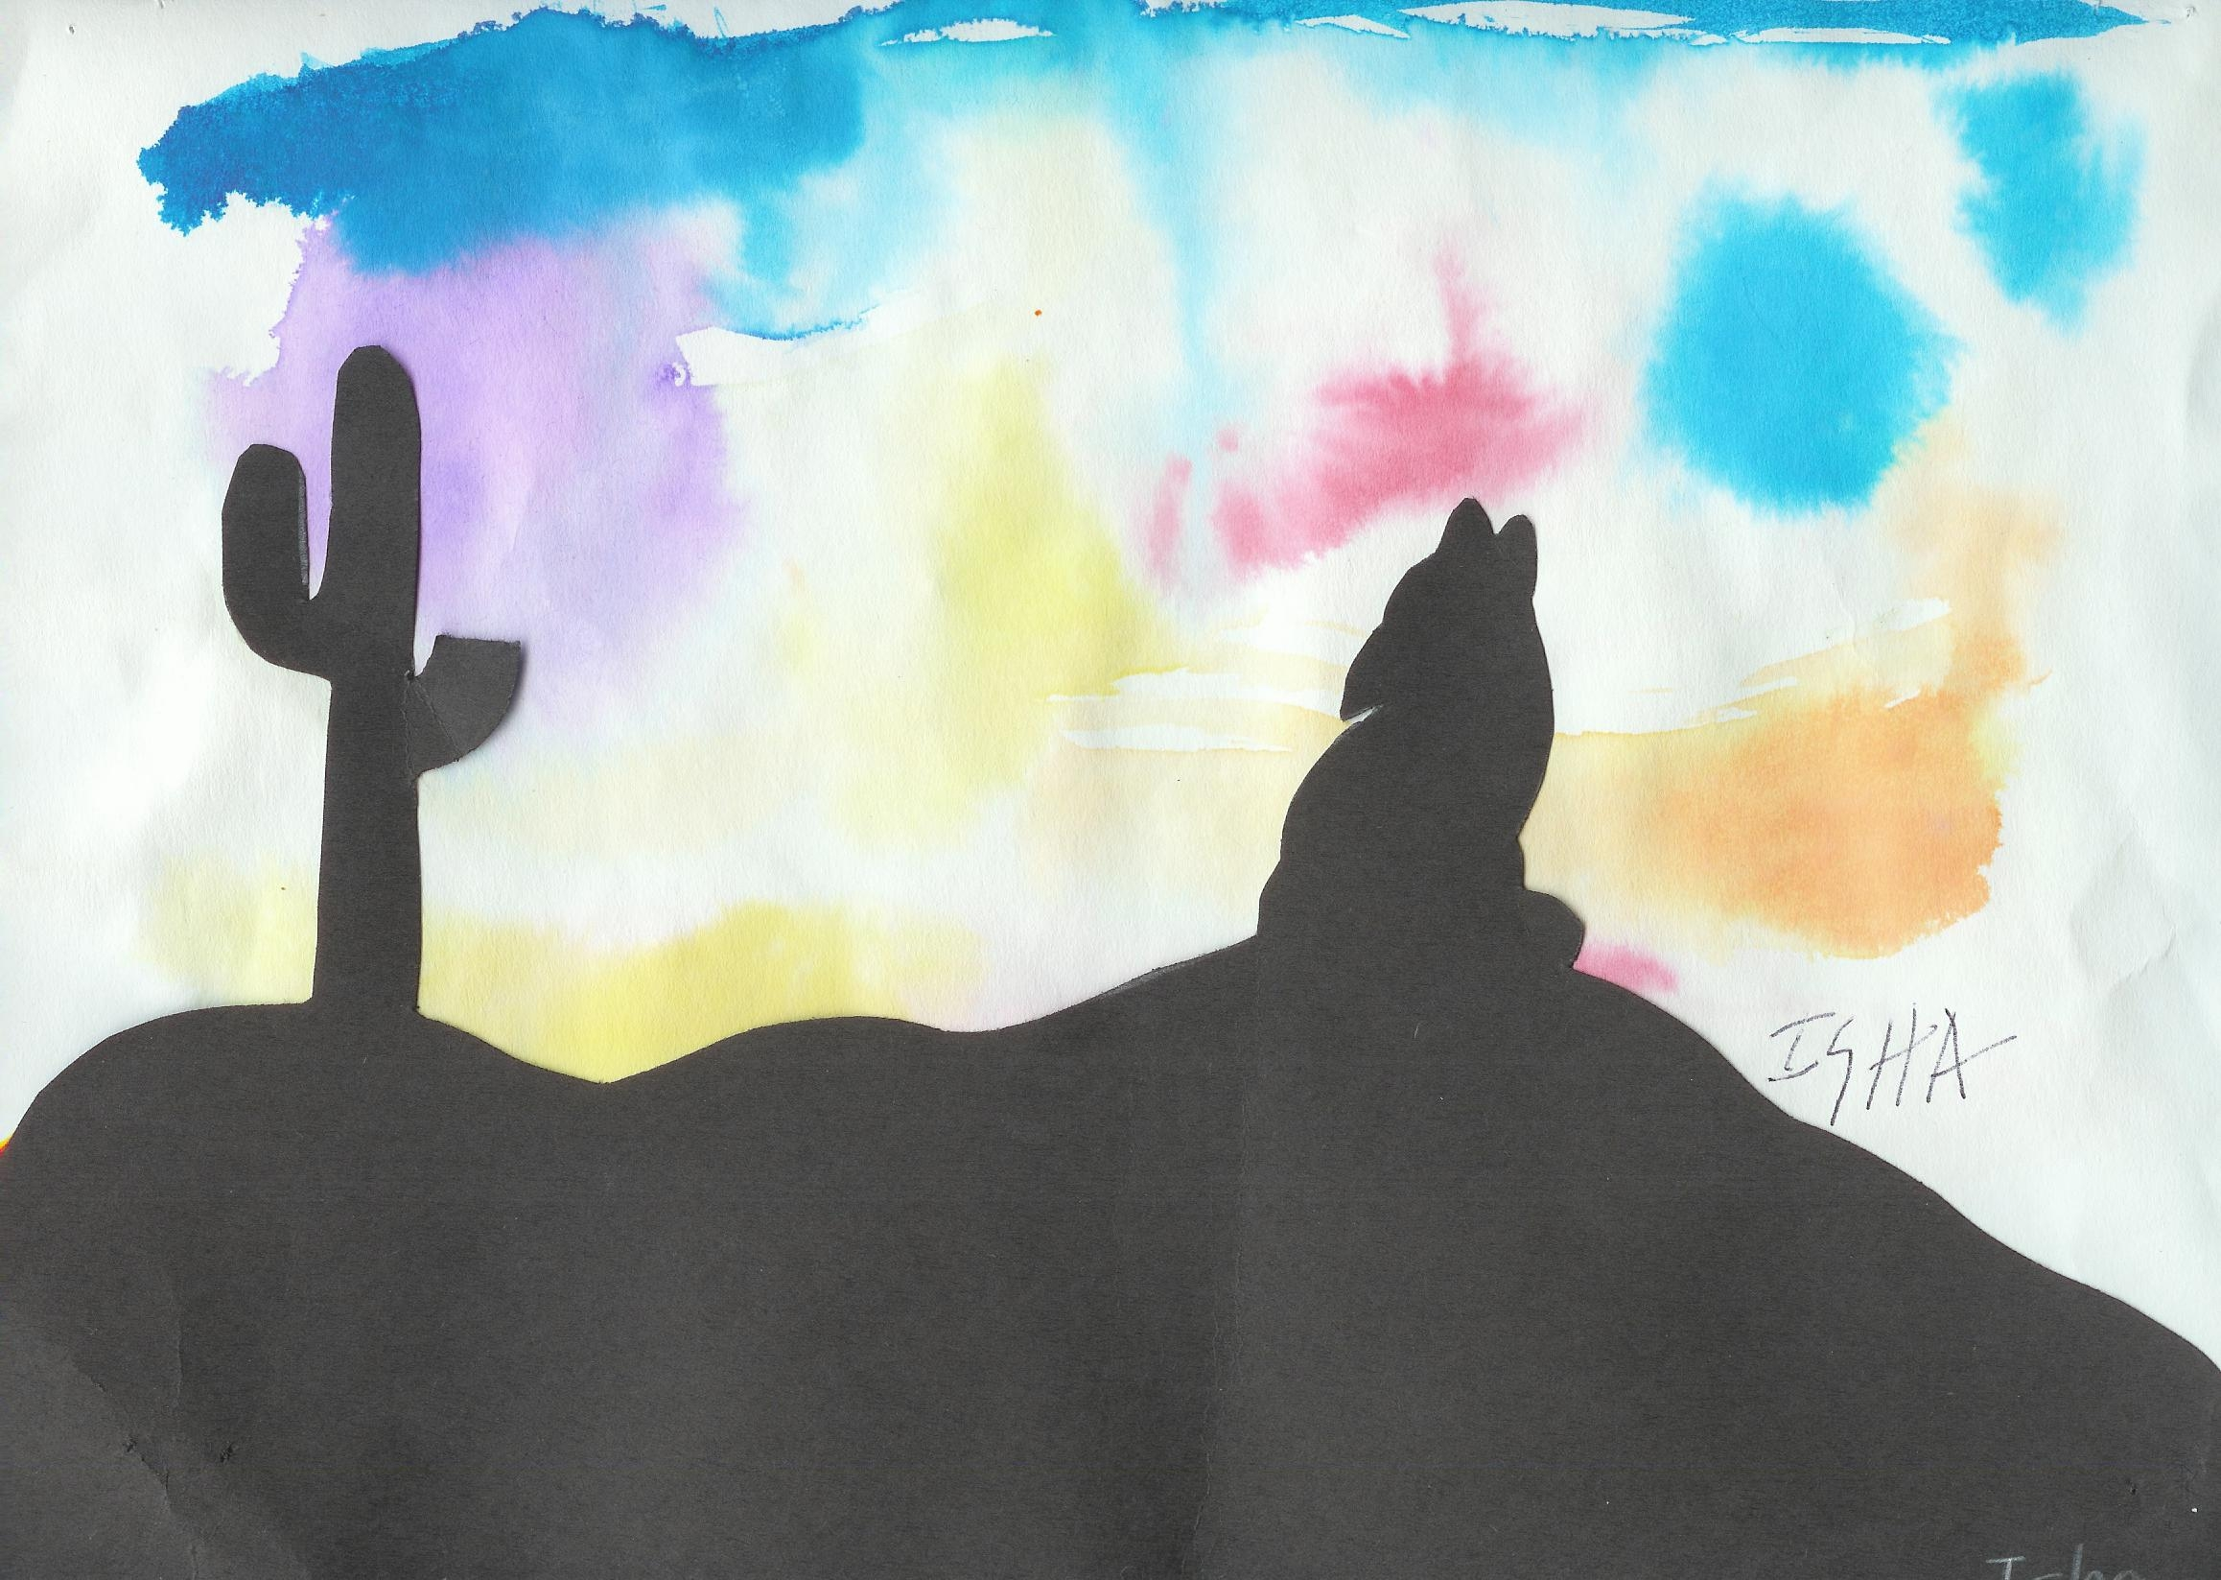
Coyote’s Howl – by Isha Chakaborty

Rain Dance
Dr. Tushar K. Ray

Come on children, soak in this rain
Come on out, on open higher field
Cloud is now, happily pouring rain
Come on children, feel Arizona rain
Here comes Love, as our precious rain
Come on out, and get now soaked in
Freely cleansing, any self-hesitation
Open up your playful heart and mind

Grasp this rain, as a gift of life
Must clear out, any type of hype
And make it only, a celebration of life
Since, life and rain is one and the same

Dance, dance, dance in this rainy rhyme
Forget the sense, as yours and mine
Be at one amid, raindrops in falling
And truly have a most wonderful time
Rain is falling, from thick gray cloud
Sometimes soft, and quite often it is loud
Sun today is barred from being out
So, enjoy the soak, and have a great fun time
------------------------------------
January 4, 2005


The boy and his drum
~ Debjani Mukherjee ~

Once upon a time, there lived a poor woman who had only one son. She worked hard cleaning houses and grinding grain for the well-to-do families in town. They gave her some grain in return and she lived on it. But she could never afford to buy nice clothes or toys for her son. Once, when she was going to the market with some grain to sell, she asked her son, "What can I get you from the market?" He promptly replied, "A drum, Mother, get me a drum."
The mother knew she would never have enough money to buy a drum for her son. She went to the market, sold the grain, and bought some gram flour and some salt. She felt sad that she was coming home empty-handed. So when she saw a nice piece of wood on the road, she picked it up and brought it home to her son. The son didn't know what to do with it.
Yet he carried it with him when he went out to play. An old woman was lighting her woodstove with some cow-dung patties. The fire was not catching and there was smoke all around and it made the old woman's eyes water. The boy stopped and asked why she was crying. She said that she couldn't light her fire and cook. The boy said, "I have a nice piece of wood and you can start your fire with it." The old woman was very pleased, lit the fire, made some bread, and gave a piece to the boy.
He took the bread and walked on till he came upon a potter's wife. Her child was crying and flailing his arms. The boy stopped and asked her why the child was crying. The potter's wife said the child was hungry and she had nothing in the house to give him. The boy gave the bread in his hand to the hungry child, who ate it eagerly and stopped crying. The potter's wife was grateful to the boy and gave him a pot.
When he walked on, he came to the river, where he saw a washerman and his wife quarreling. The boy stopped and asked the man why he was scolding and beating his wife. The washerman said, "This woman broke the only pot we had. Now I've nothing to boil my clothes in before I wash them." The boy said, "Here, don't quarrel, take this pot and use it." The washerman was very happy to get a large pot. He gave the boy a coat in return.
The boy walked on. He soon came to a bridge, where he saw a man shivering in the cold without so much as a shirt on him. He asked the man what had happened to his shirt, and the man said, "I was coming to the city on this horse. Robbers attacked me and took everything, even my shirt." The boy said, "Don't worry. You can have this coat." The man took the coat and said, "You're very kind, and I want to give you this horse."
The boy took the horse, and very soon he ran into a wedding party with the musicians, the bridegroom, and his family, but all of them were sitting under a tree with long faces. The boy stopped and asked why they looked so depressed. The bridegroom's father said, "We're all set to go in a wedding procession. But we need a horse for the bridegroom. The man who was supposed to bring it hasn't arrived. The bridegroom can't arrive on foot. It's getting late, and we'll miss the auspicious hour for the wedding." So the boy offered them his horse, and they were delighted. When the bridegroom asked him what he could do in return, the boy said, "You can give me something: that drum your musician is carrying." The bridegroom had no trouble persuading the drummer to give the drum to the boy. The drummer knew he could easily buy another with the money he was going to get.
The boy now rushed home to his mother, beating his new drum, and told her how he got it, beginning with a piece of wood from the roadside.

~~~~ * ~~~~



Rainy Day
Dr. Tushar K. Ray

As top-top-rain kept on falling,
In monotonous tone
Then moments became truly heavy
In my study room
Hey, winds today took vacation
Birds forgot flying motion
Sitting on the damp tree branch
They were all in gloom

My Raja, the cat became lazy
With no place to go
The yard was water-logged
What could he do?
His comfort place, small canopy
Where he spends hours happy
That was just wet and messy
Nothing he could do

The murky cloud is thinning out
For the sun to shine out
Soon air flowing, the birds singing
Would Raja be playing out
The wet yard is now looking better
On Raja’s canopy floor
The kids by now are tired of home
Should soon be outdoors!
-----------------------------
January 3, 2005


Our Vibrant Mother-Earth
Dr. Tushar K. Ray

“Get your acts together, oh my stubborn children”
Is the latest Tsunami-warning to us from ailing Mother Earth
Or else, she has to use tough-love to change our course
And then we wouldn’t have any choice but to conform

Tsunami’s wrath is a serious case of major warning to us
While minor ones are often in effect all over our globe
Causing quakes, volcanic outbreaks, floods and storms
As ailing Mother gets her balance restored as time goes on

This Universe is a holistic network linked at the quantum level
Coupled deeply in turn, to our collective universal mind
Where thought and action of the humankind plays a critical role
Affecting the health of Mother Earth in a subtle significant way

Mother Earth is eternally vibrant in her acute feedback poise
With all her soulful companion souls embraced in her bosom
Where men with severe greed are the problem-maker type
Upsetting her normal balance, so creating unnecessary stress

Manmade discord is the root cause for many of Nature’s fury
That ailing Earth has to recover from by releasing own stress
And resultant perils must be lessons for keeping our greed at bay
So, man may learn from given misery and learn to honor her way
-------------------------------------------------
January 10, 2005

By Trisha Dasgupta (4th grade)
Laughter …
___________________________________________
Laughter sets the spirit free to move through even the most tragic of circumstances.
--Unknown
Father: Son you had promised to behave yourself at the party, and you haven't, have you?
Son: No, father.
Father: And I promised to spank you if you didn't behave, so what have you got to say?
Son: Well, as I've broken my promise, I won't mind if you break yours!
Q. Why can't your nose be 12 inches long?
A. Because then it would be a foot!
Doctor, Doctor my son has swallowed my pen, what should I do?
Use a pencil till I get there.
How did your mom know you hadn't washed your face?
I forgot to wet the soap!
Father: How were the exam questions?
Son: Easy
Father: Then why look so unhappy?
Son: The questions didn't give me any trouble, just the answers!
Teacher: Can anyone tell me how many seconds there are in a year ?
Pupil: 12 - 2nd January, 2nd February...!
Great news, teacher says we have a test today come rain or shine.
So what's so great about that?
It's snowing outside!
Teacher: Name an animal that lives in Lapland!
Pupil: A reindeer
Teacher: Good, now name another.
Class: Another reindeer!
What kind of lighting did Noah use for the ark?
Floodlights!
Why aren't you doing very well in history?
Because the teacher keeps asking about things that happened before I was born!

Prayer
Tushar K. Ray

Shattering the darkness of my ignorance
Thou come into view, Oh my Lord
In the moment of my most needed awareness
Illuminating my consciousness, and
Letting me blossom like a lotus in the sun again

I embrace Thee with all my petals, my Lord
Please accept my heart and oblige me
By giving me a tiny space at your blessed feet!
So, I can stay blossomed all day and night!
By holding on to Thy wholesome feet
-----------------------------------------
December 29, 2004
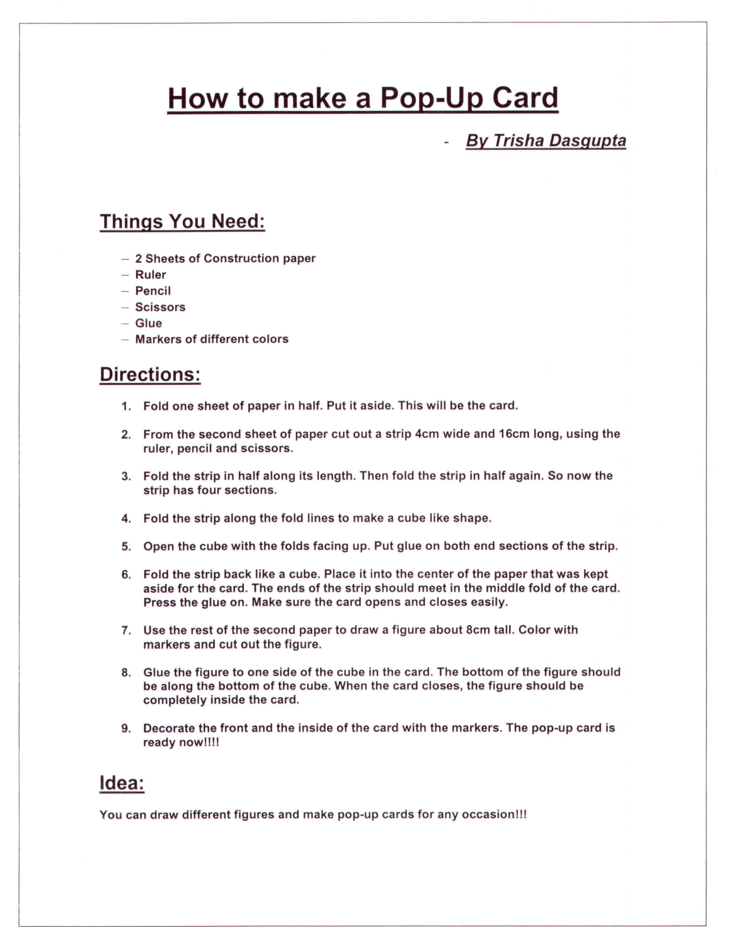

Riddles
________________________________________________________________
- I can run, but never walk,
Often a murmur, never talk,
I have a bed but never sleep,
I have a mouth but never eat.
What am I?
- Twelve pears hanging high. Twelve men passing by. Each took a pear and left eleven hanging there. How can that be?
- Where is the best place to see a man eating fish?
- It has seven letters,
It proceeded God,
All poor people have it,
And all rich people need it.
WHAT IS IT?
- Why do Chinese men eat more rice than Japanese men?
- Ramu walked for thirty minutes in the pouring rain without getting a single hair on his head wet. He didn't have a hat or an umbrella and his coat had no hood. In fact he had nothing to protect his head. How did he do that?
- It is in the rock, but not in the stone,
It is in the marrow, but not in the bone,
It is in the bolster, but not in the bed; ,
It is not in the living, nor yet in the dead,
What is it? ,
- What gets bigger and bigger as you take more away from it?

- How many letters are in the alphabet?

- If you were running a race, and you passed the person in 2nd place, what place would you be in now?
Answers on page 41

Puppies for Sale
Unknown Author
A farmer had some puppies he needed to sell. He painted a sign advertising the pups and set about nailing it to a post on the edge of his yard. As he was driving the last nail into the post, he felt a tug on his overalls. He looked down into the eyes of a little boy.
Mister," he said, "I want to buy one of your puppies."
"Well," said the farmer, as he rubbed the sweat off the back of his neck, "these puppies come from fine parents and cost a good deal of money."
The boy dropped his head for a moment. Then reaching deep into his pocket, he pulled out a handful of change and held it up to the farmer. "I've got thirty-nine cents. Is that enough to take a look?"
"Sure," said the farmer.
And with that he let out a whistle, "Here, Dolly!" he called.
Out from the doghouse and down the ramp ran Dolly followed by four little balls of fur. The little boy pressed his face against the chain link fence. His eyes danced with delight.
As the dogs made their way to the fence, the little boy noticed something else stirring inside the doghouse. Slowly another little ball appeared; this One noticeably smaller. Down the ramp it slid. Then in a somewhat awkward manner the little pup began hobbling toward the others, doing its best to catch up....
"I want that one," the little boy said, pointing to the runt.
The farmer knelt down at the boy's side and said, "Son, you don't want that puppy. He will never be able to run and play with you like these other dogs would."
With that the little boy stepped back from the fence, reached down, and began rolling up one leg of his trousers. In doing so he revealed a steel brace running down both sides of his leg attaching itself to a specially made shoe. Looking back up at the farmer, he said, "You see sir, I don't run too well myself, and he will need someone who understands."

The world is full of people who need someone who understands.



Stories of the Witty Gopal
as told by Purnima Hazra

One day a thief came to Gopal’s house while he was sleeping. Gopal became aware of the thief but he pretended to continue to be asleep. The thief stole a lot of Gopal’s things and left. Gopal quietly followed him. When the thief reached his own home, he set Gopal’s things on the floor, lay down on his bed and went to sleep. Gopal also lay down next to the thief and slept.
In the morning the thief woke and seeing Gopal asked him “ Hey, who are you?”
Gopal replied, “ I am the person whose house you robbed last night. When I saw all my things at your house, I mistook it for my own house and came in to sleep.”
The thief was very ashamed and apologized to Gopal and returned all this things.

~ * ~

Once, an extremely obese man from a nearby village came to see Gopal.
“Please help me Gopal. I have heard that you are very talented and can cure almost anything”, he said. “Please, I am so fat; I cannot do anything in peace. It hurts to even walk. Please, please, only you can cure me. Please make me thin.”
Gopal examined the man, and then said with a very serious face,” I am really sorry sir. Your condition is really bad. You have just 30 days to live. I just cannot do anything for you”.
The man went pale, and begged Gopal to save him. But Gopal said he just could not. The man went home and took to his bed. He gave up eating and drinking and just wasted away as he waited for death.
A month passed. The man suddenly realized that more than 30 days had passed and he was still alive. He rushed to Gopal and said,” You no good man! You fraud! You have absolutely NO talent. You said I would be dead in 30 days, but a month has passed and I am still alive”.
Gopal smiled and took the man to a mirror. The man saw his refection; he had lost all his weight in last month. Now he understood Gopal’s trick and thanked him for making him lose weight.

~ * ~

One day a group of merchants from Arabia came to see the Sultan. They were horse traders and sold the Sultan many fine Arabian horses. The Sultan was very pleased with the horses. He wanted to have more Arabian horses.
The merchants said to the Sultan, ”Sire, it is a very expensive journey for us to bring you the horses. If you can pay us for the horses in advance, we will surely bring them for you. The Sultan gladly gave them a 100 mohurs (gold coins).

Next day, as Gopal accompanied the Sultan on his evening stroll, he suggested to the Sultan that it would be nice to have a list of all the fools in the country. Immediately the Sultan gave the task of compiling such a list to Gopal. Gopal returned the next day with a 26 page list. The Sultan’s name was at the top of the list.
“What, why have you put my name on the top of this list of fools?” thundered the Sultan.
“Well, Sire, anyone who would give such a large sum of money to total strangers from foreign lands, the 100 mohurs you gave the horse traders yesterday, deserves his name in this list”, replied Gopal calmly.
“But what if they do return with the horses?” asked the Sultan.
“Then, Sire, I will remove your name from the list and add theirs”.

~~~~ * ~~~~

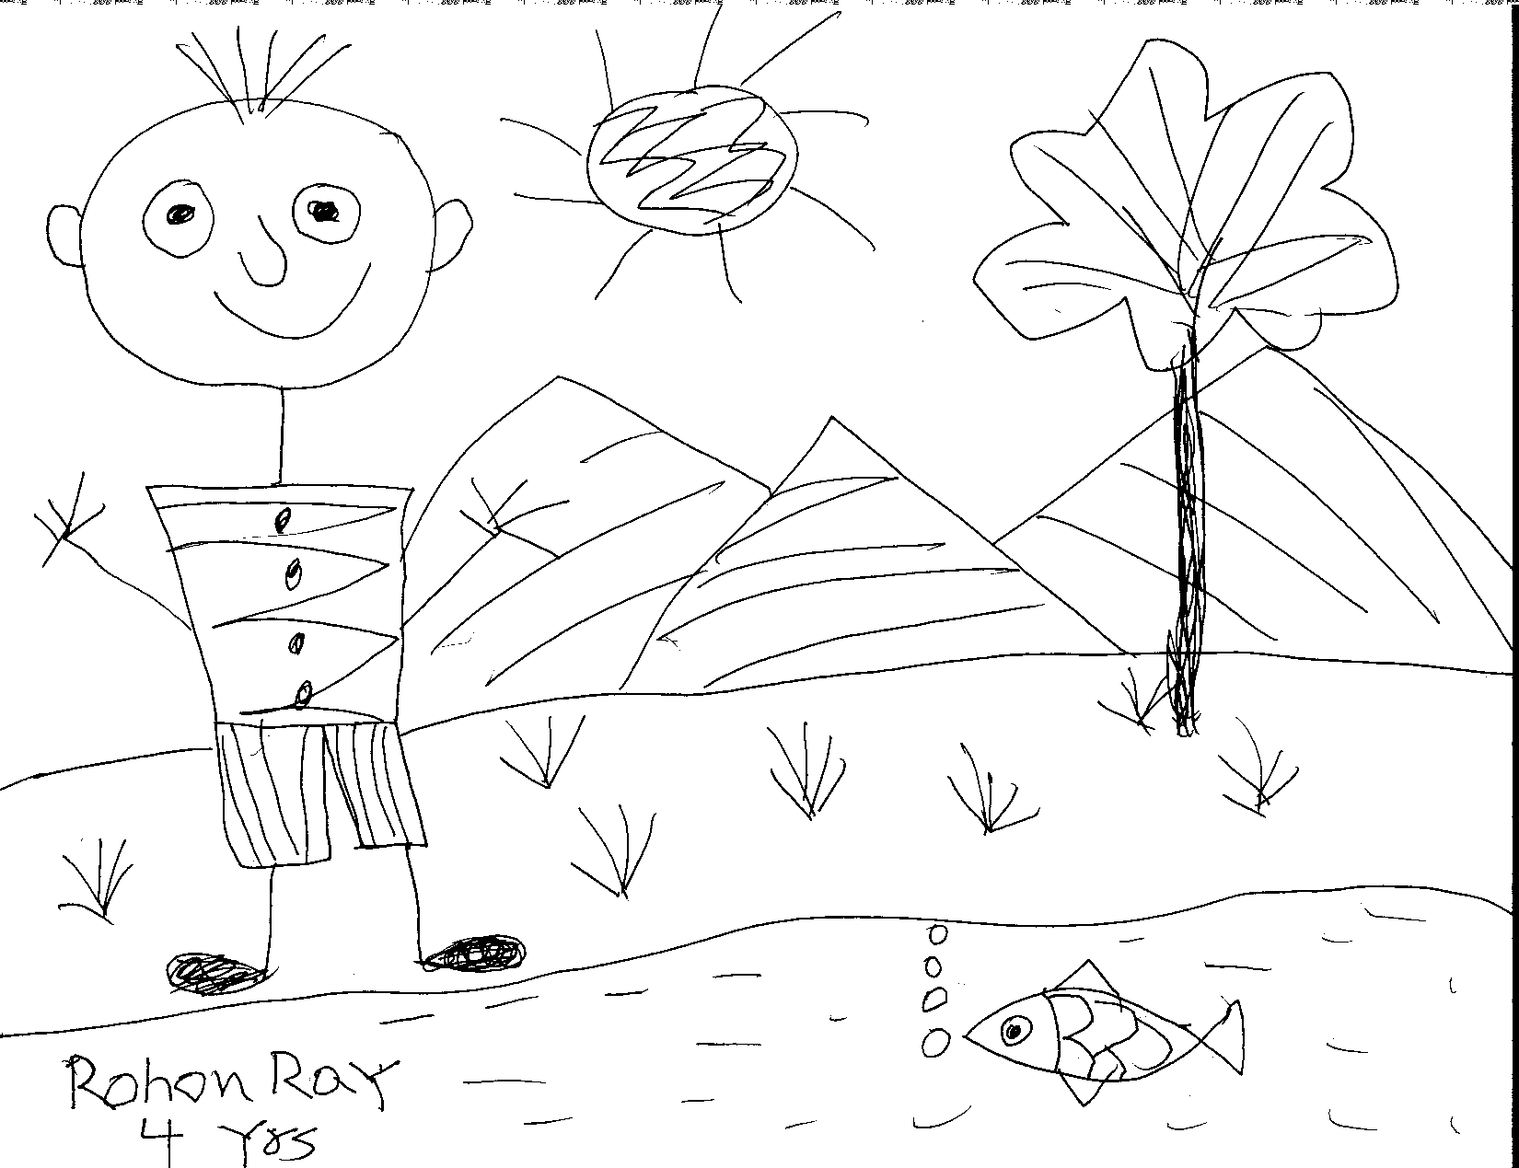

Artwork by Rohon Roy (4 yrs.)

Food for the Mind
_________________________________
~ Compiled by Debashis Chowdhury ~

- A man builds a house rectangular in shape. All sides have southern exposure. A big bear walks by, what color is the bear? Why?
- A cherry is inside a wine glass as shown. Can you move two matchsticks so that the cherry is now outside the glass.

- If there are 3 apples and you take away 2, how many do you have?
- A fish is swimming upwards as shown. Can you move three matchsticks to make it head in the opposite direction?

- I have two US coins totaling 55 cents. One is not a nickel. What are the coins?
- Can you move six matchsticks to convert the two wine glasses into a house?

- If you have only one match and you walked into a room where there was an oil burner, a kerosene lamp, and a wood burning stove, which one would you light first?
- Here are 9 matchsticks arranged to form three equilateral triangles. Can you move three to form four equilateral triangles?

- A doctor gives you three pills telling you to take one every half hour. How long would it take you to finish all the pills?
- A farmer has 17 sheep, and all but 9 die. How many are left?
Answers on page 40

Two Frogs
Old Indian Folktale … compiled by Sarbari Chowdhury

A group of frogs were traveling through the woods, and two of them
fell into a deep pit. When the other frogs saw how deep the pit
was, they told the two frogs that they were as good as dead. The
two frogs ignored the comments and tried to jump up out of the pit
with all their might. The other frogs kept telling them to stop,
that they were as good as dead. Finally, one of the frogs took
heed to what the other frogs were saying and gave up. He fell down
and died.
The other frog continued to jump as hard as he could. Once again,
the crowd of frogs yelled at him to stop the pain and just die. He
jumped even harder and finally made it out. When he got out, the
other frogs said, "Did you not hear us?" The frog explained to
them that he was hard of hearing. He thought they were encouraging him the
entire time.
This story teaches two lessons:
There is power of life and death in the tongue. An encouraging
word to someone who is down can lift them up and help them make it
through the day.
A destructive word to someone who is down can be what it takes
to kill them.
Be careful of what you say. The power of words... it is sometimes hard to understand that an encouraging word can go such a long way. Anyone can speak words that tend to rob another of the spirit to continue in
difficult times. Special is the individual who will take the time
to encourage another.


Answers to Puzzles
- A house with all sides facing south must be at the North Pole. Only Polar bears – White in Color – even come close.

- You only have the two that you took away

- A half dollar and a nickel! Only one is not a nickel

- He would light the match first

- One hour from start to finish
- Nine

Answers to Riddles

1. A river
2. ‘Each’ was a man’s name.
3. In a sea-food restaurant
4. Nothing
5. The population of China is larger than the population of Japan.
6. He was bald.
7. The letter ‘r’
8. A hole
9. There are 11 letters in "THE ALPHABET" Did you say 26?
10. Second (did you say first?)



